Report on the outcomes of a Short-Term Scientific Mission

Action number: CA18232
Grantee name: Catherine Drysdale

Details of the STSM
Title: Computation of Spectra and Data Driven Models for the HPA axis
Start and end date: 15/10/2023 to 21/10/2023

Description of the work carried out during the STSM
Description of the activities carried out during the STSM. Any deviations from the initial working plan shall also be described in this section.
(max. 500 words)
During the STSM, we determined the pseudospectra by doing DMD for two sets of data. The first set of data was of 10 patients who underwent heart surgery, and the second set of data was from seven healthy participants. The purpose of looking at these two data sets was to really understand the limitations of the DMD algorithm, which produces a linear operator that represents the system based on the data. A brief description of the DMD algorithm is as follows; take data in the form of a snapshot sequence;$V_{1}^{N}= \{ v_{1},v_{2}, …, v_{n}\}$
- Split the time series of data in $V_{1}^{N}$ into two matrices $V_{1}^{N-1}$ and $V_{2}^{N}$ .
- Compute the SVD of $V_{1}^{N-1}=U ΣW^{T}$.
- Form the matrix $\tilde{S}=U^{T} V_{2}W Σ^{-1}$
- The i-th DMD eigenvalue is $λ_{i}$ and the $i$-th DMD mode is the $U y_{i}$.
As we only have two variables (ACTH and Cortisol), we have to use delay-embedding to enrich the data set in both cases. For biological systems that represent systems with delays where the noise is dirty, this is fundamentally suspect. A way of validating this is to see whether or not the data is reconstructed by the pseudomodes.
Regarding the data from the heart surgery patients, the levels of ACTH and Cortisol formed three distinct categories regarding the one-pulse group, the two-pulse group and the multi-pulse group (see Figure 1, the columns from left to right correspond to the two-pulse group, the single pulse group and the multi-pulse group respectively). For the one-pulse pattern, the effect of the inflammatory mediators is important only in the single pulse pattern. We calculated the eigenvalues of the matrix obtained from DMD as well as the Kreiss constant (shown in Figure 1). The Kreiss constant is a lower bound on the maximum amplification possible from the linear operator. We did not see a correspondence between the Kreiss constants for the linear operators, established via DMD, and the distinct groups.
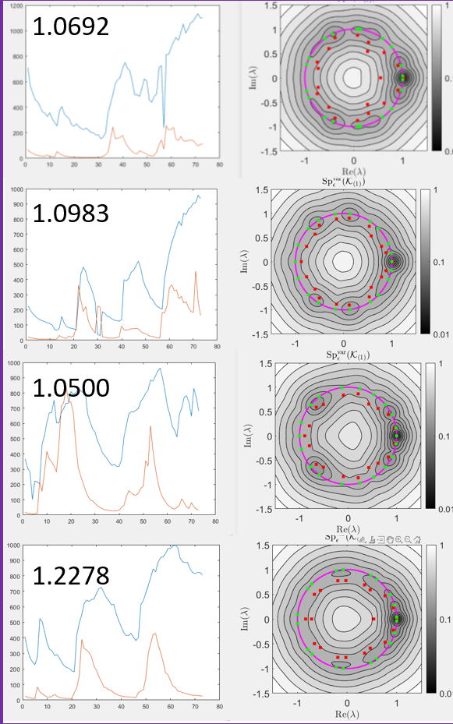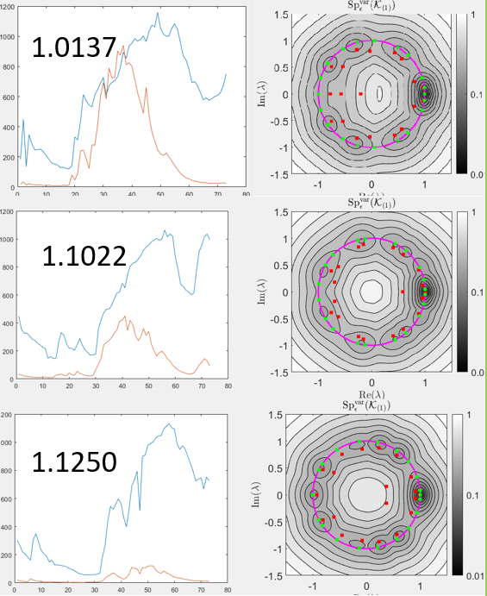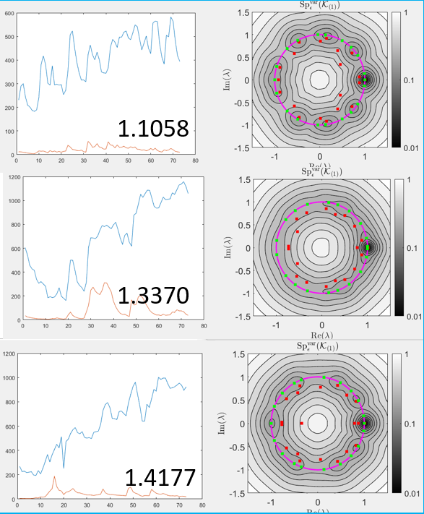
Figure 1. ACHT levels (orange) and Cortisol levels (blue) along with the pseudospectra plots for the heart surgery patients.
What these plots demonstrated was a certain degree of bio-variability. Similar bio-variability held for the healthy participants, which is demonstrated from the pseudospectra plots (See figure 2).
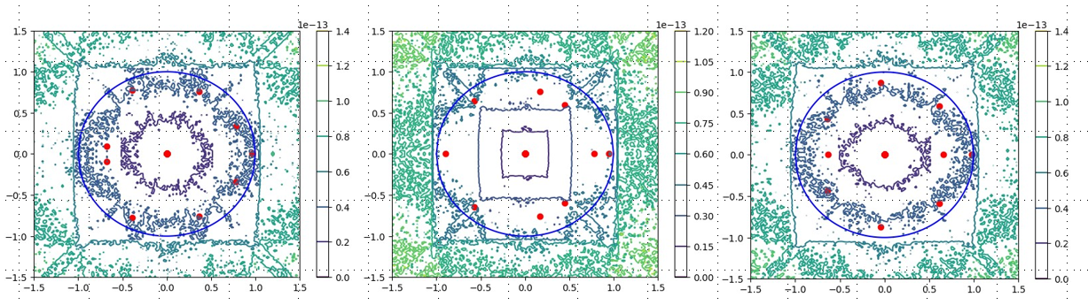
Figure 2. Different pseudospectra patterns for healthy participants.
This corresponds to the first step in the original proposal. The pseudospectra modes did not reconstruct the original data well enough for a clinical application, so we need to change tactic. We also were pressed for time regarding fixing the spectral pollution using ResDMD so this has been moved to the follow up activities. As Fourier modes reconstructed the data well, we intend to use a type of ResDMD that is based on convolution coordinates to enrich the data set as opposed to the delay embedding. These correspond to using convolutional coordinates as the Fourier modes reconstruct the data. We will discuss more about this in the next section.
Description of the STSM main achievements and planned follow-up activities
Description and assessment of whether the STSM achieved its planned goals and expected outcomes, including specific contribution to Action objective and deliverables, or publications resulting from the STSM. Agreed plans for future follow-up collaborations shall also be described in this section.
(max. 500 words)
The main achievements of the STSM can be summarised as preliminary computations demonstrated above as well as a new understanding of the problem. Both approaches (pseudospectra and DMD) give us a way of probing underlying models and giving us some quantification of perturbation via the Kreiss constant. However, we have learned valuable things regarding the limitations of both methodologies; Firstly, the perturbation quantified by pseudospectra does not necessarily correspond to physical perturbation even when calculated from dmd modes. For instance, in the case of the heart surgery patients, there was no correspondence between the size of the perturbation demonstrated by the Kreiss constant and the transient effects experienced by the patients. However, there is a chance to explore structured pseudospectra to recreate some physical perturbations (this idea was initially laid out in the plan, but we did not accomplish this in this STSM). However, this requires a model first, and we intend to do this with the model outlined in the proposal. Additionally, regarding DMD, we are limited to the data so often it is impossible to tell whether there are multiple fixed points or attractors (we only see what attractor we are in). This has issues regarding the potential applications for control. We are keen to create a new algorithm that solves this particular problem, which is in line with the objectives of WG5 and WG2 (the development of numerical methods around nonlinear problems). An approach we are going to take is making the dictionary of observables in the DMD algorithm more similar to functions on the right-hand-side of the dynamical systems in the mathematical models. We hope that these functions will help us explore the phase space fully and not be restricted to which fixed point the system is in.
On a more positive note, we did find the pseudospectra, in particular the Kreiss constant, is a good indicator of bio-variability on a person-to-person level. Talking to Eder Zavala, we are going to incorporate pseudospectra into a bigger grant proposal to explore this subject of bio-variability with regards to recovery from sleep deprivation. In this project, the objective will be looking at variability itself as opposed to trying to recreate data.
This STSM also facilitated several outcomes written in the original proposal including the new academic environment and also the creation of the paper focussing on this aspect of bio-variability. Furthermore, the research of this STSM was disseminated at the post-doc symposium at the University of Birmingham and the plan will be followed to present the results again on bio-variability at the Society of Mathematical Biology (SMB) Annual meeting.
This project will be continued as the member has been invited to give a seminar in Cambridge where she will work with Matthew Colbrook again over a period of days and they also intend to have weekly zoom meetings.

This report is submitted by the grantee to the Action MC for approval and for claiming payment of the awarded grant. The Grant Awarding Coordinator coordinates the evaluation of this report on behalf of the Action MC and instructs the GH for payment of the Grant.

