Report on the outcomes of a Short-Term Scientific Mission

Action number: CA18232
Grantee name: Catherine Drysdale

Details of the STSM
Title: Numerical investigation of the explosive behaviour of a time-evolution convection-diffusion
problem.
Start and end date: 25/10/2022 to 28/10/2022

Description of the work carried out during the STSM
Description of the activities carried out during the STSM. Any deviations from the initial working plan shall also be described in this section.
(max. 500 words)
We computed the pseudospectra of the operator
$$L u=(u^{'} sin{x)'+u' }$$
On a suitable domain $D\left(L\right)$ of the segment [$-π,π].$ We used the orthonormal basis $\{e_{n}\}_{-N}^{N}⊂D\left(L\right), where e_{n}=\frac{e^{inx}}{2π}$, and a block reduction taking into consideration the symmetries of the operator, so the index $n∈\{1,…,N\}$ only. This gives projected matrices $L$ and$M(z)$ with the following entries. $L_{kj}=⟨e_{k},L e_{j}⟩$ and $M_{kj}(z)=⟨ \left(L-z\right)e_{k},(L-z)e_{j}⟩$, where $z$ is a complex number. Both these matrices provide information about the pseudospectrum of our operator as we describe next.
The pseudospectra of the matrix $L$is a numerical approximation of the pseudospectra of the operator. Moreover, for any complex $z$the smallest eigenvalue of $M\left(z\right)$ will be an upper bound for the singular values of the operator $(L-z)$ hence will certify points within the level lines of these pseudospectra. Concretely, for $σ_{1}\left(z\right)=\min{Spec\left(M\left(z\right)\right),}$ and $z∈C$, the condition $σ_{1}\left(z\right)≤ϵ,$implies $z∈Spec_{ϵ} L$.

We calculated the pseudospectra and singular values using the Numpy package in Python and took values of $z$ on a rectangular grid. We include an example of a picture in Figure 1 of a pseudospectra drawn on a coarse grid. Numerical parameters and labels are given in plot. We see that, whilst the picture shows reasonable behaviour around the eigenvalues, the computational code was not optimised to show what is shown by the current consensus; that the boundaries should be made of curves asymptotically close to parabolas fitting the cures of the system. In order to do this, we need to optimise the code so it works on a contour-tracing basis, but also such that it can deal with much bigger computational domains.
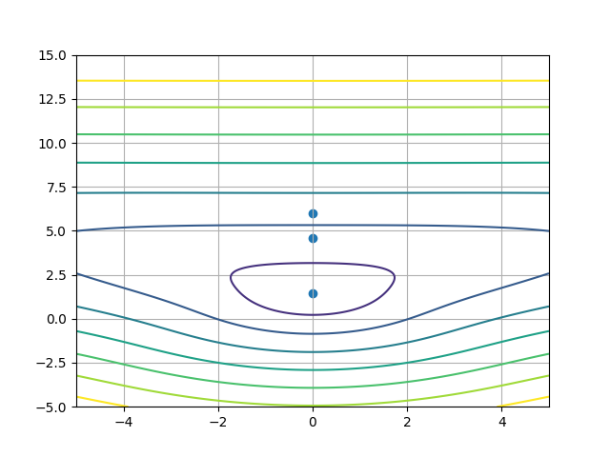
Figure 1. ($N = 100$ Fourier modes, $x∈\left(-5, 5\right)$ and $y∈(-5, 15)$, with a square grid of spacing 0.1. The levels correspond to $ϵ∈(1, 10)$ with epsilon decreasing from the centre. The blue dots correspond to the numerically computed eigenvalues.)
We also considered different scaling, namely,
$$L\left(h\right)u=h^{2}(u^{'} sin{x)'+h u' }$$
for small values of $h$, as this in particular results in the contour around the lowest eigenvalues being more pointed. However, for the same choice of computational domain was not big enough to see our conjectured asymptotic pseudospectra. As a future component of the research, we will investigate rigorously how large a domain is needed.
We also did not get around to computing the pseudospectra of the operator of the form
$$L u=(u^{'}{x)'+u' },$$
owing to lack of time. In this case, we were hoping to consider some kind of quasi-basis that may be elucidated by transforming an operator that of Bessel-type.

Description of the STSM main achievements and planned follow-up activities
Description and assessment of whether the STSM achieved its planned goals and expected outcomes, including specific contribution to Action objective and deliverables, or publications resulting from the STSM. Agreed plans for future follow-up collaborations shall also be described in this section.
(max. 500 words)
The main achievement of the STSM was to get a bound on the pseudospectrum of $L$ and thereby understand its asymptotic behaviour. For this we determined a robust certification mechanism given by the function $σ_{1}\left(z\right)=\min{Spec\left(M\left(z\right)\right)}$. The specific contribution to the action objective was regarding Working Groups 1 and Working Groups 5 through the task to “develop appropriate numerical methods for applications”. Furthermore, now we believe that we have the numerical machinery, we can consider the time-dependent problem and also the perturbation problem.
We hope to create a short paper from this STSM based on the thought process regarding obtaining these bounds on the pseudospectra. For this, we intend to incorporate runnings of the codes we created with a longer computational time and also use come contour plotting algorithms that will allow us to compute the pseudospectra for a specific $ϵ$ in a more rigorous way. We suspect that with some of the images, the grid method is giving erroneous results particularly given small values of $ϵ$. Also, we are interested in the behaviour far away from the origin as it is conjectured that this would grow as we move further away from the origin.
In order to facilitate this collaboration, Lyonell Boulton and I will continue with our weekly meetings in the way that we did before online, but as well as this we plan another meeting in December that shall be financed by the Heriot-Watt Applied Math Seminar budget.
After we complete this case, we will consider the second operator
$$L u=(u^{'}{x)'+u' },$$
as we believe that this can be possibly a good example of where a quasi-basis would be of numerical assistance to elucidate phenomena and allow us to compute robustly pseudospectra and eigenvalues. We will again facilitate most of this collaboration online.

This report is submitted by the grantee to the Action MC for approval and for claiming payment of the awarded grant. The Grant Awarding Coordinator coordinates the evaluation of this report on behalf of the Action MC and instructs the GH for payment of the Grant.

